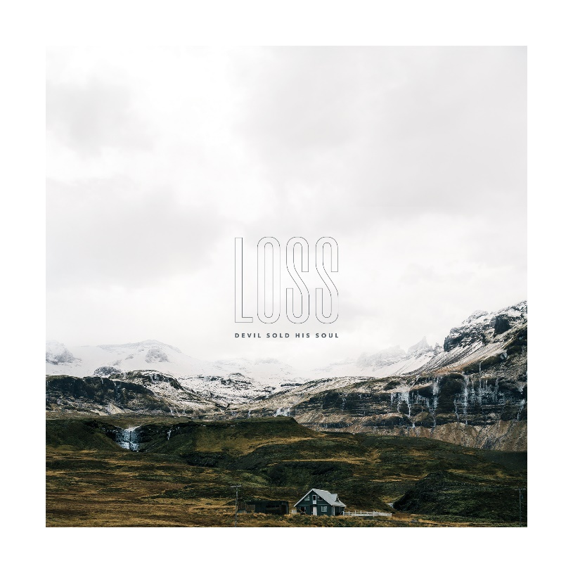

DEVIL SOLD HIS SOUL
»Loss«

VÖ: April 09th 2021

Line-up: | DEVIL SOLD HIS SOUL online:
Rick Chapple – Guitar, Piano  Jonny Renshaw - Guitar  Alex Wood - Drums  Jozef Norocky - Bass  Paul Green – Vocals  Ed Gibbs - Vocals | www.devilsoldhissoul.com  www.facebook.com/devilsoldhissoul  www.nuclearblast.de/devilsoldhissoul  www.instagram.com/dshs_official/

DEVIL SOLD HIS SOUL (London, UK) blend huge soundscapes, earth-shattering riffs and soaring melodies.

DEVIL SOLD HIS SOUL begin a new chapter in their highly-acclaimed career, signing to metal heavyweights Nuclear Blast Records. 2021 will see the band release their fourth studio album ‘Loss’, their first with the dual vocal attack of Ed Gibbs and Paul Green.
DEVIL SOLD HIS SOUL burst onto the UK underground metal and hardcore scene in 2004 growing a cult following from their first record, ‘Darkness Prevails’ EP released through Visible Noise (BRING ME THE HORIZON) in 2005. Their debut album, ‘A Fragile Hope’ saw the band take their position as one of the most respected underground bands in the UK with their visceral and captivating live shows. DEVIL SOLD HIS SOUL’s sophomore album, ‘Blessed and Cursed’, elevated their sound and audience to new heights, voted into RockSound Magazine’s top 10 albums of 2010.
In 2012 the band unleashed their third self-produced album, ‘Empire Of Light’. Received to critical acclaim across the board, the album cemented their position as one of the UK’s most respected and revered metal acts.
With Ed Gibbs departing the band early in the year, 2013 saw the first new material featuring singer Paul Green with single ‘Time’, followed by 2014’s ‘Belong Betray’ EP and 2016’s ‘The Reckoning’. After welcoming Gibbs back to sing on the 2017 ‘A Fragile Hope’ anniversary tour, the band asked Gibbs to continue the dual vocals with Green for the remaining festivals and tours that year, with the line-up then becoming a permanent fixture.
2018 saw the band travel beyond Europe with their first touring in Asia, they also began to put the foundations down on what would become their new record ‘Loss’. Written about the struggles faced in recent years, ‘Loss’ treads familiar ground and explores exciting new territories for DEVIL SOLD HIS SOUL, including for the first time the dual vocals of Gibbs and Green on record. Recorded, engineered and mixed by guitarist Jonny Renshaw at his UK based Bandit Studios, DEVIL SOLD HIS SOUL have poured heart and sincerity into every atom of this their fourth album, with song writing elevated to new levels.

The album meanders through a narrative of personal loss, grief, and the process of healing, it touches on mental health and the anxiety in us all. Though the album is deeply personal and reflective of some dark times, ‘Loss’ is still positive and full of uplifting melody and vigour. It is defiant, bold, and intertwined with the topics that connect us all as humans.

‘’When we started the process of writing Loss, we hadn’t really set ourselves a theme, it was probably going to end up being a collection of the best songs we could write over a period but with no common thread”, singer Paul Green states. However, in the years these 10 tracks developed, the band lost several family members. The emotional impact that had on the songs, from the instrumentals to the lyrics is there to see. “The songs were a catharsis, they also allowed us to communicate the things that we found hard to speak about in person, they’re a snap shot in time to help us remember the ones we‘ve loved and lost”, he continues. “We hope the album resonates with people and can help those that are navigating their own grief.”

But ‘Loss’ dives even deeper into the labyrinthine abysses of being alive. “Like many people mental health issues have had an impact on our lives. I thought for a long time it wasn’t something that would ever affect me, I didn’t appreciate or understand the weight of it until I was faced with my own issues and seeing others who I thought were immune, suffering themselves”, Paul says. The song ‘Witness Marks’ puts out the band’s own experiences, not only their own battles but also the struggles they see day to day – often unnoticed. “From the person smiling on social media with a deep sadness in their eyes, to the ones that struggle to speak up in their silence who have forgotten what it’s like to be ok. Depression and anxiety are mountains to climb, we hope these new songs connect with the listener and help them on that journey”, he adds.

The feeling of ‘Loss’ is ever present in life, whether it be through death, the breakdown of relationships, to the loss of control over your mental health. As individuals our lives our interspersed with it and how we cope with its fallout is all unique to the person. We grieve loss in some way, no matter how small the event. “The 10 songs that appear on ‘Loss’ were all written with that theme in mind. Several tracks were written in memory of family we’ve lost over the last few years, several touch on issues with mental health and loss of control over the things we had taken for granted.”, Paul closes.

Having toured with the likes of CULT OF LUNA, ARCHITECTS, NORMA JEAN, BRING ME THE HORIZON, UNDEROATH, GALLOWS, ENVY and EMMURE, as well as headlining a stage at DOWNLOAD FESTIVAL l (UK) and numerous European festival appearances including SUMMER BREEZE and WITH FULL FORCE (Germany) and PUKKELPOP (Belgium), DEVIL SOLD HIS SOUL have built a huge reputation for their captivating live shows, over 16 years:

"Only the sky catching fire may give a visual to match the scale of the soundtrack ... this was the kind of gig that changed lives.” Kerrang! Magazine

